

Practices for Secure Software Report

Table of Contents
Document Revision History 3
Client 3
Instructions 3
Developer 4
1. Algorithm Cipher 4
2. Certificate Generation 4
3. Deploy Cipher 4
4. Secure Communications 4
5. Secondary Testing 4
6. Functional Testing 4
7. Summary 4
8. Industry Standard Best Practices 4

Document Revision History

Version | Date | Author | Comments
1.0 | 10/16/26 | Allison Wright

Client



Instructions

Submit this completed practices for secure software report. Replace the bracketed text with the relevant information. You must document your process for writing secure communications and refactoring code that complies with software security testing protocols.

- Respond to the steps outlined below and include your findings.
- Respond using your own words. You may also choose to include images or supporting materials. If you include them, make certain to insert them in all the relevant locations in the document.
- Refer to the Project Two Guidelines and Rubric for more detailed instructions about each section of the template.

Developer
Allison Wright

Algorithm Cipher

When it comes to choosing an effective encryption algorithm for Artemis Financial, SHA-256 is a strong option. It helps protect sensitive information from unauthorized access, an important consideration for a global financial program. Here’s a quick overview: SHA-256 is a hashing algorithm that creates a 256-bit hash value from any input data. In other words, it transforms information into a fixed-length string of characters. This output, called a hash, is unique to the input data and can help verify data integrity.

At the bit level, SHA-256 produces a 256-bit hash, providing a strong layer of security. Hash functions like SHA-256 are designed to work in one direction, so once data has been hashed, it cannot easily be reversed or decrypted. This adds another layer of protection.

It’s also helpful to understand the types of keys used in encryption. Symmetric keys use the same key to encrypt and decrypt plaintext. AES-256, for example, is a widely used symmetric encryption standard known for its strong security. Asymmetric encryption, by contrast, uses a pair of keys: a public key and a private key. It’s commonly used to secure internet connections.

Encryption has a fascinating history, stretching back to ancient times. As early as 600 BC, the Spartans used devices such as the scytale to send secret messages. The field has advanced considerably since then, particularly during World War II. By the 1970s, IBM had developed modern encryption methods that helped pave the way for today’s security standards.

In summary, SHA-256 supports Artemis Financial’s security needs and builds on a well-established field that has evolved over thousands of years.

Certificate Generation
Insert a screenshot below of the CER file.

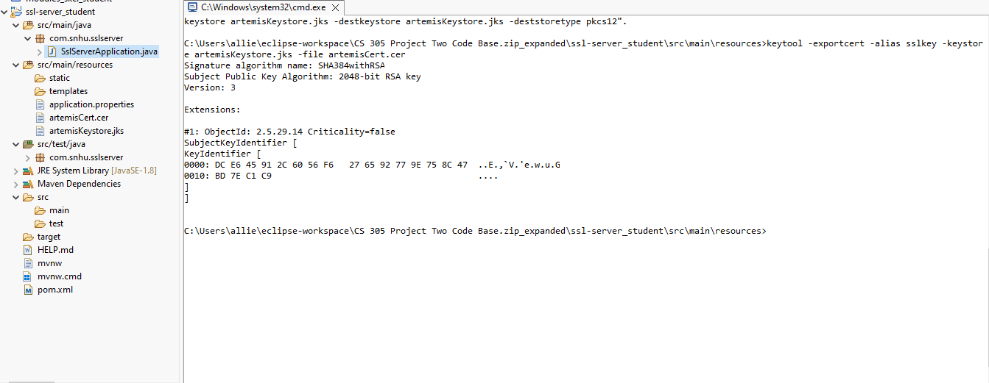

Deploy Cipher
Insert a screenshot below of the checksum verification.

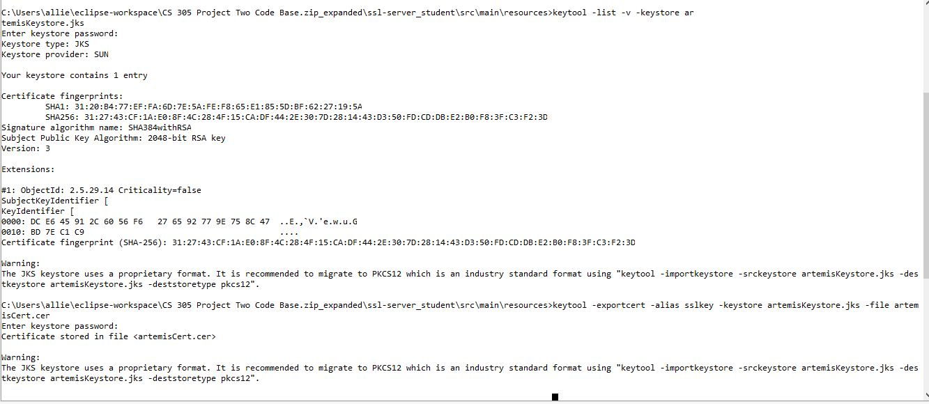

Secure Communications
Insert a screenshot below of the web browser that shows a secure webpage.

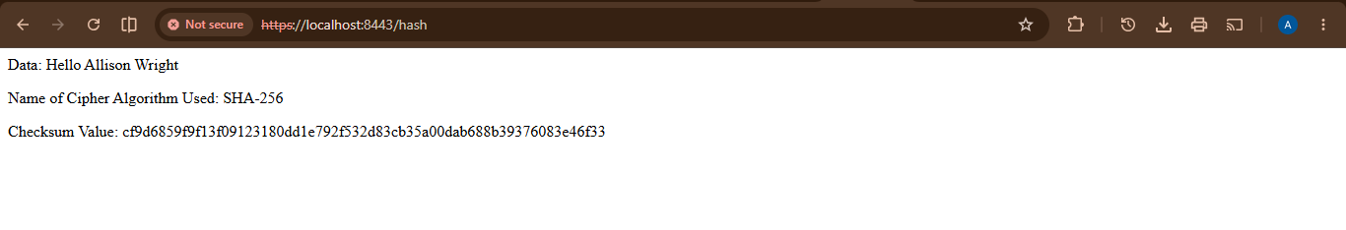

Secondary Testing
Insert screenshots below of the refactored code executed without errors and the dependency-check report.
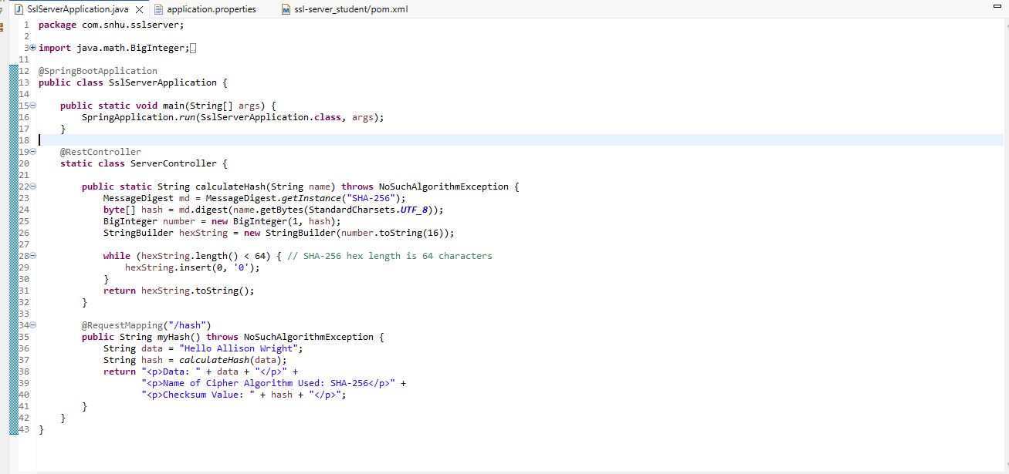
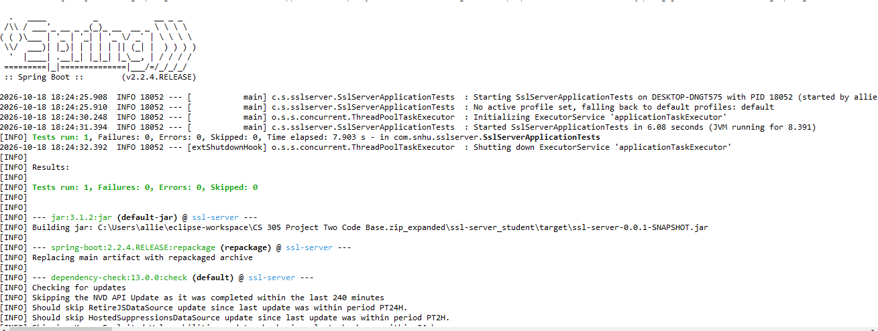
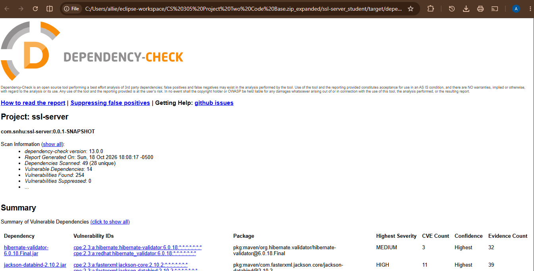

Functional Testing
Insert a screenshot below of the refactored code executed without errors.

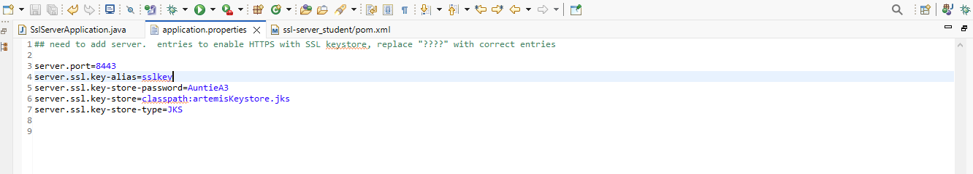

Summary

I just did some refactoring and added a secure RestController to the SSLServerApplication.java file to handle the hash RESTful endpoint. This new ServerController class tackles the security concerns we spotted in the Vulnerability Assessment Diagram and meets the required standards. I decided to go with SHA-256 for hashing since it’s super reliable, and I kept the code nice and simple to minimize any potential risks. Also, I updated the Maven Dependency Check from version 5.3.0 to 13.0.0 to make sure we’re using the latest version.

Industry Standard Best Practices

To keep our software secure and tackle any known vulnerabilities, I’ve implemented some good industry-standard practices for secure coding. Beyond the changes mentioned in the Summary, we should take several key steps to keep our app secure. First, we must always validate and sanitize user inputs to protect against attacks like SQL injection and XSS, ensuring our app can manage anything that comes its way. Furthermore, we should enforce strong password policies, utilize hashing algorithms, and consider multi-factor authentication (MFA) to enhance user access control. Adopting the principle of least privilege is also essential, as it ensures users and applications only have the necessary permissions to perform their tasks, reducing the risk of unauthorized access. Secure data storage and transmission are critical; we should encrypt sensitive data at rest with robust encryption algorithms and use secure communication methods like HTTPS. Regular updates and patching of our software and its dependencies are crucial for addressing vulnerabilities and minimizing risk. Additionally, implementing effective error handling can prevent the leakage of sensitive information, while maintaining secure logging practices allows us to monitor potential security threats. By following these best practices for secure coding, we’re not just protecting sensitive information; we’re also ensuring compliance with regulations, reducing costs, and building trust with our customers and partners, all of which contribute to a positive brand image and enhance the company’s reputation.

Sources:
Dworkin, M. J., Barker, E. B., Nechvatal, J. R., Foti, J., Bassham, L. E., E. Roback, & Dray, J. F. (2001, November 26). Advanced encryption standard (AES). Federal Inf. Process. Stds. (NIST FIPS) - 197. https://www.nist.gov/publications/advanced-encryption-standard-aes
GeeksforGeeks. (2023, May 13). Difference between AES and RSA encryption. GeeksforGeeks. https://www.geeksforgeeks.org/computer-networks/difference-between-aes-and-rsa-encryption/
GeeksforGeeks. (2024, July 16). Advanced encryption standard (AES). GeeksforGeeks. https://www.geeksforgeeks.org/advanced-encryption-standard-aes/
Schneider, J. (2024, July 17). The history of cryptography | IBM. IBM. Ibm.Com. https://www.ibm.com/think/topics/cryptography-history

